Inclusive participation
Junior Council Capacity Strengthening and Induction
Junior Council is a dynamic platform for young leaders to engage in governance, voice their ideas, and contribute to community development.


Youths doing sanitary wear
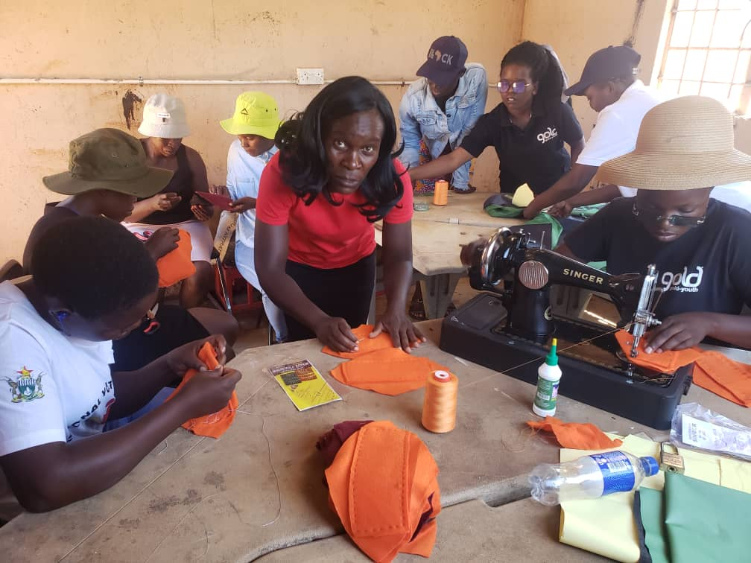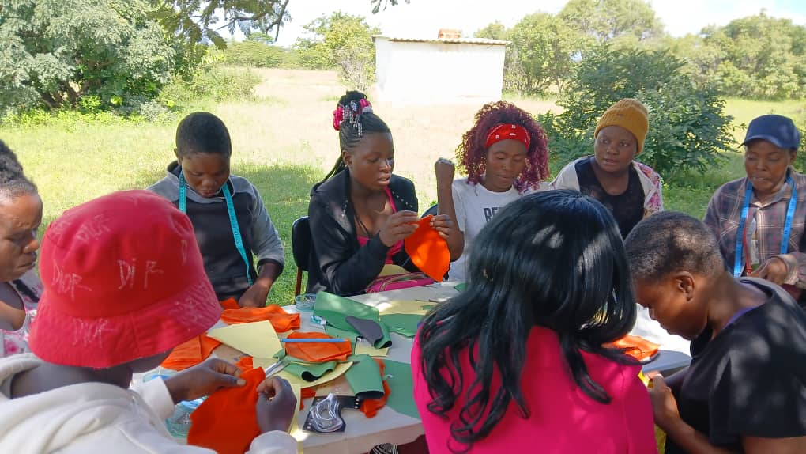

Person with disability
She’s a young community leader and advocate, the issues addressed centered around the exclusion and marginalization of two key groups: adolescent girls and young women (AGYW), and persons with disabilities.
